* **MAULANA AZAD NATIONAL INSTITUTE OF TECHNOLOGY**

**Name:** Vivek Kumar Ahirwar **Scholar No:** 191112419

**Department:** CSE **Section:**3

**Semester:** 4th **Subject:** DBMS Lab

**Date:** 18/01/2020

|  |  |  |
| --- | --- | --- |
| **Subject** | **DBMS LAB** | **Session: Jan 2021** |
| **Sub. Code:** | **CSE-227** | **Semester: IV (CSE)** |
| **Name of Teacher** | **Dr. Sweta Jain, & Dr. Nikhil Kumar Singh** |  |

DBMS: LAB-ASSIGNMENT 2

**Prog2: Insert approximate 20 recode of distinct student of different (CSE, EC, ME and CE) branch and city (Bhopal, Jabalpur, Indore, Delhi and etc) , address, state (accordingly )and pin code (accordingly).**

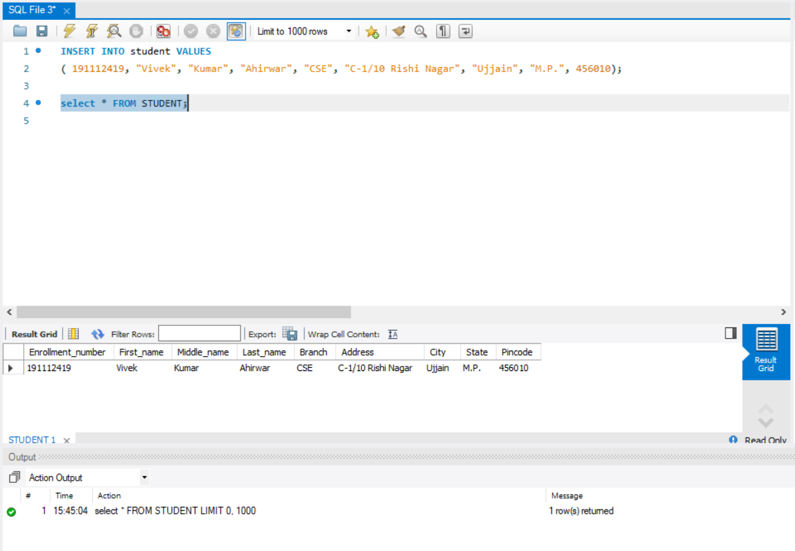

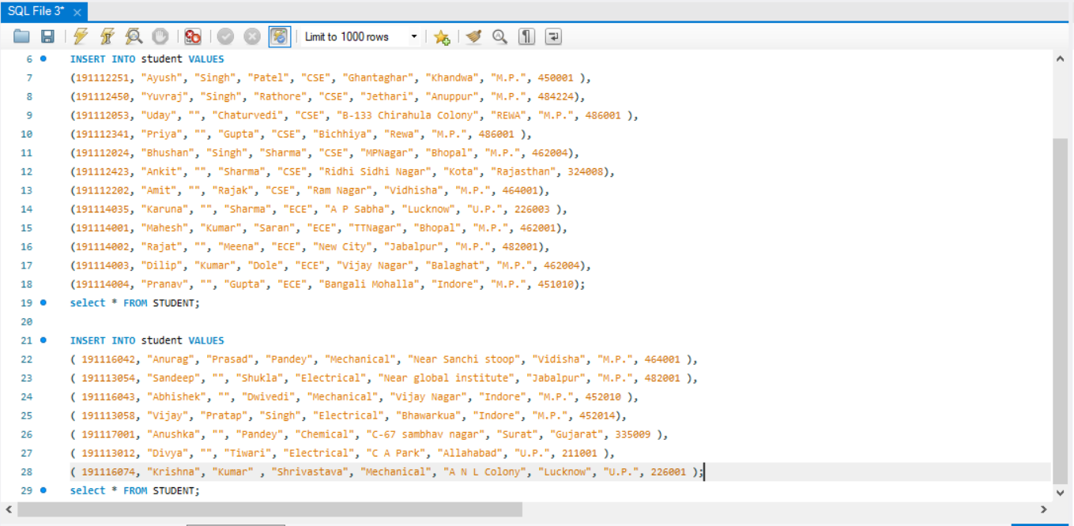

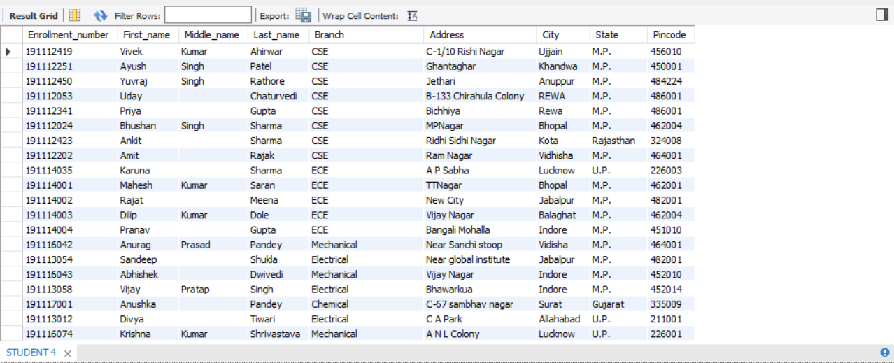

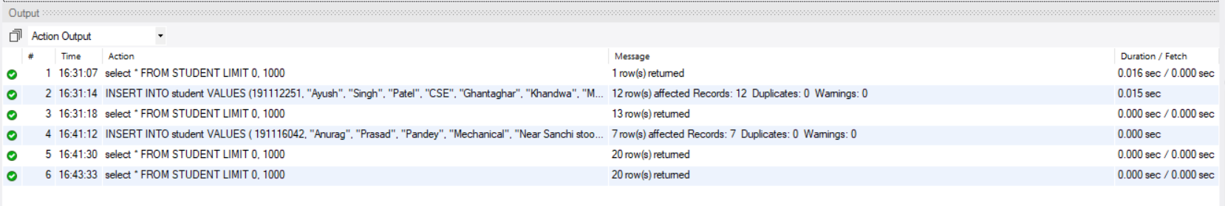

**Prog.3:** Create one table as ‘**Rolllist’** with reference of student class

Student

|  |  |
| --- | --- |
| Enrollment number | Int(20) |
| First_name | Varchar(20) |
| Middle_name | Varchar(20) |
| Last_name | Varchar(20) |
| Branch | Varchar(20) |
| Address | Varchar(40) |
| City | Varchar(20) |
| State | Varchar(20) |
| Pincode | Int(20) |

Rolllist

|  |  |
| --- | --- |
| Enrollment number | Int(20) |
| First_name | Varchar(20) |
| Middle_name | Varchar(20) |
| Last_name | Varchar(20) |

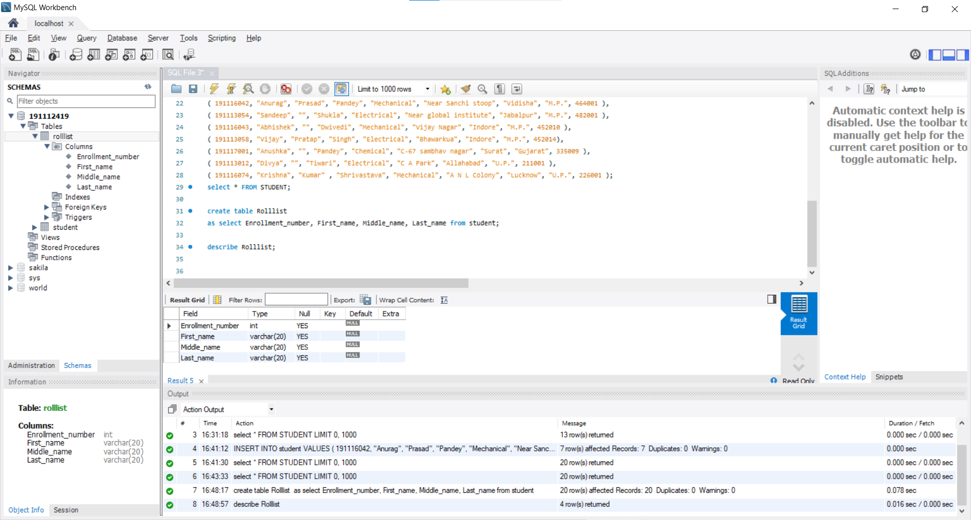

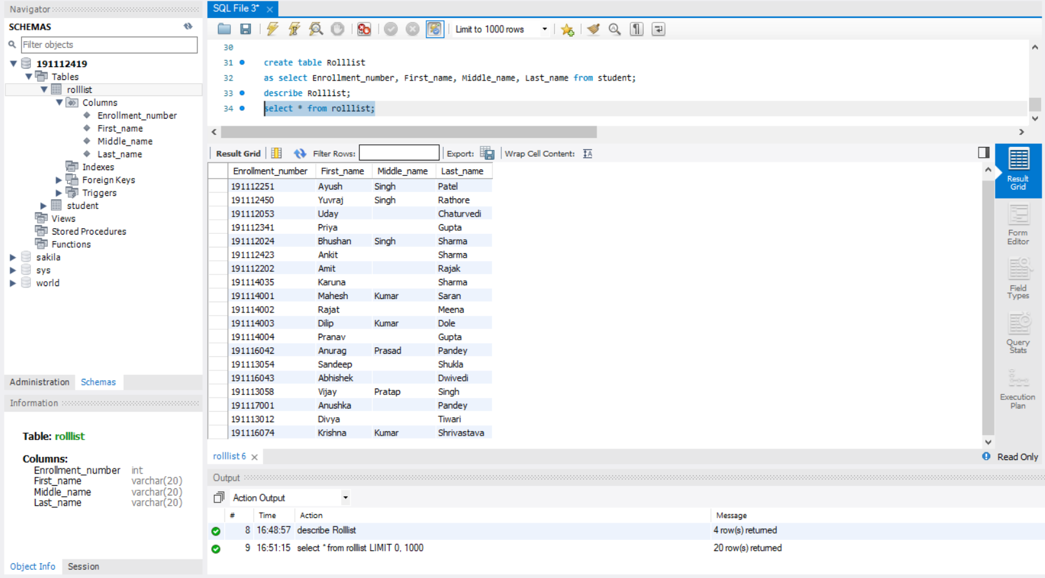

**Prog.4:** Create one table as ‘**CSE’** with reference of student class having record of all student of CSE branch as

CSE

|  |  |
| --- | --- |
| Enrollment number | Int(20) |
| First_name | Varchar(20) |
| Middle_name | Varchar(20) |
| Last_name | Varchar(20) |

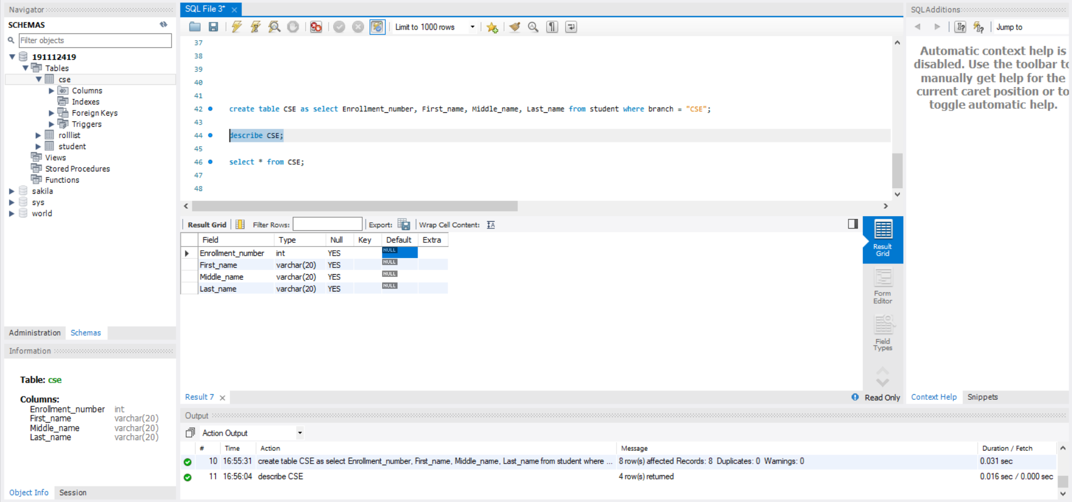

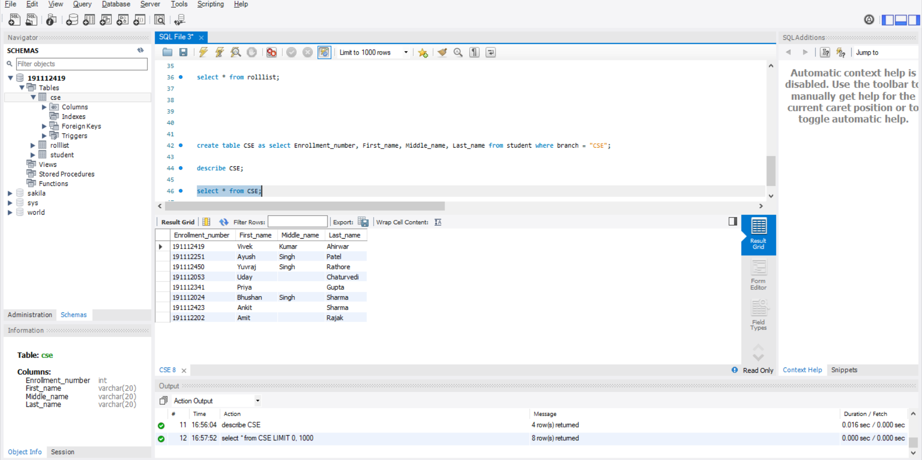

**Prog.4:** Alter table ‘**CSE’** to

1. To add email-id as attributes

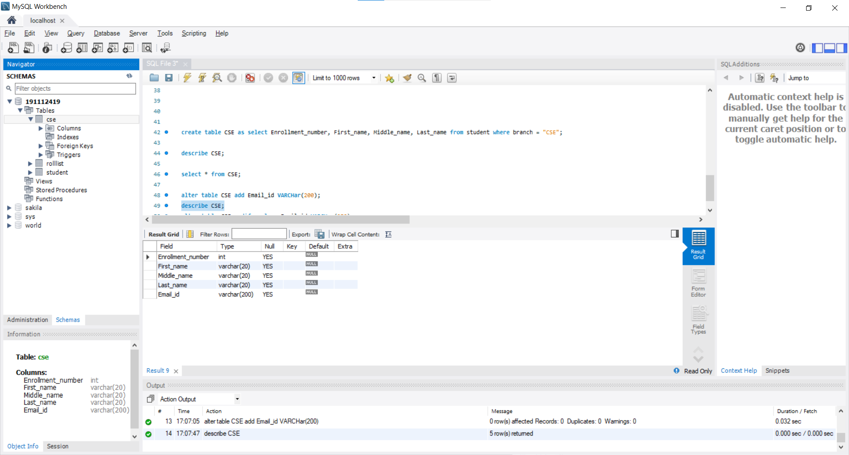

1. To modify email-id datatype

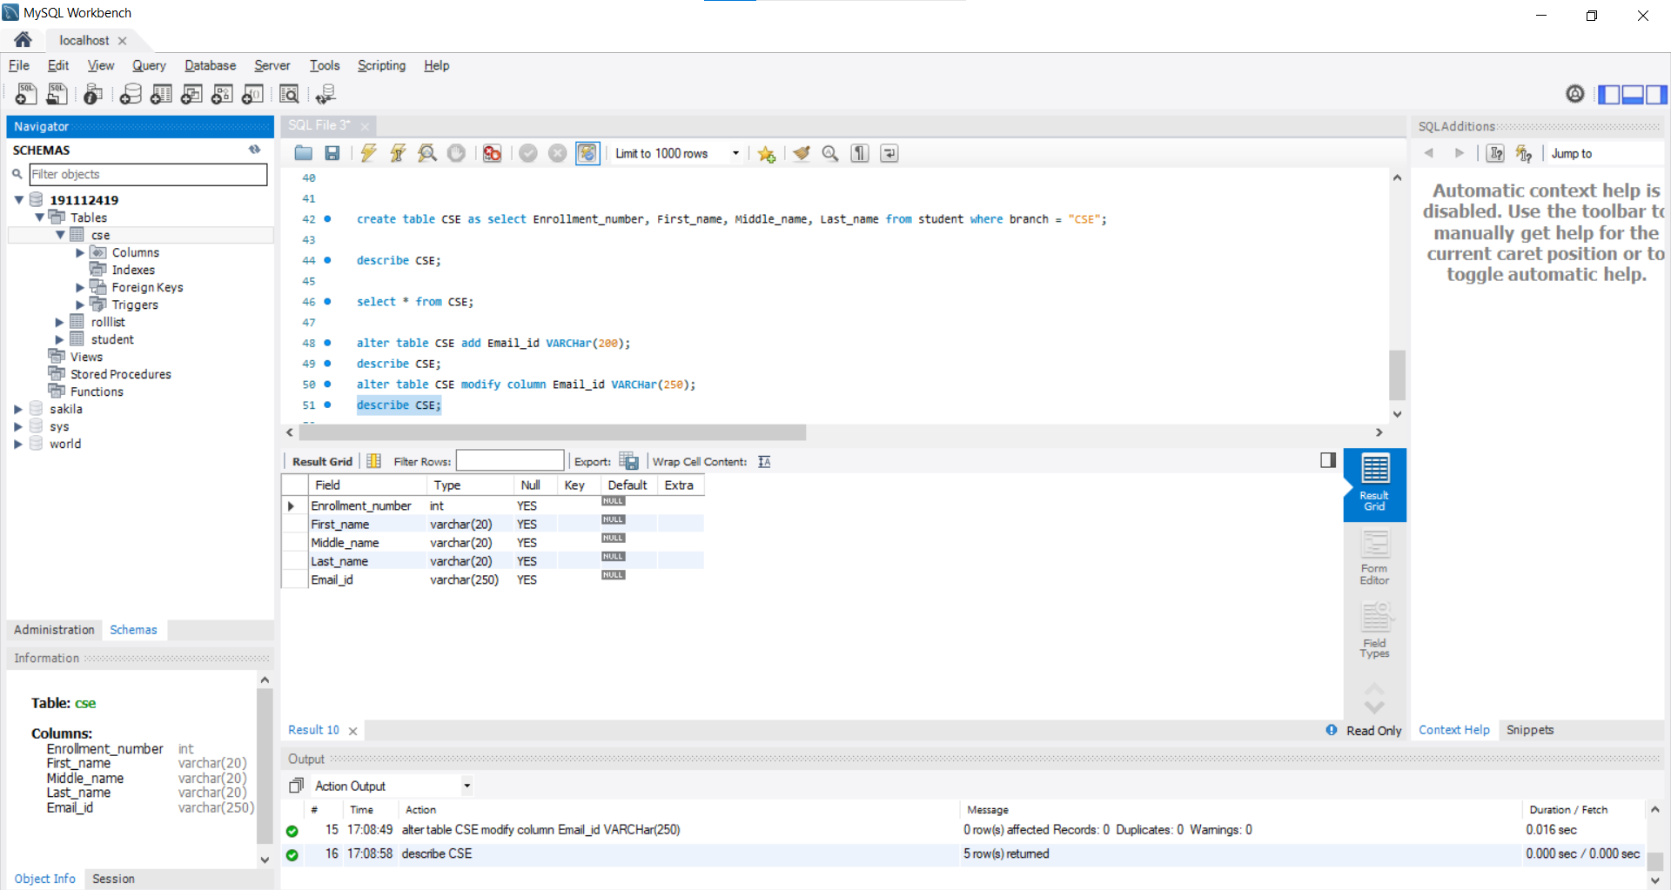

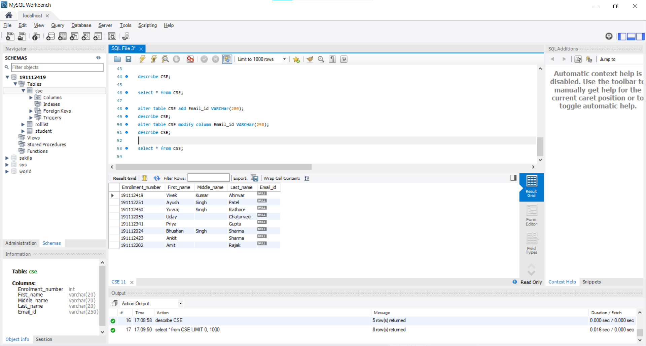

1. Drop the attribute email-id

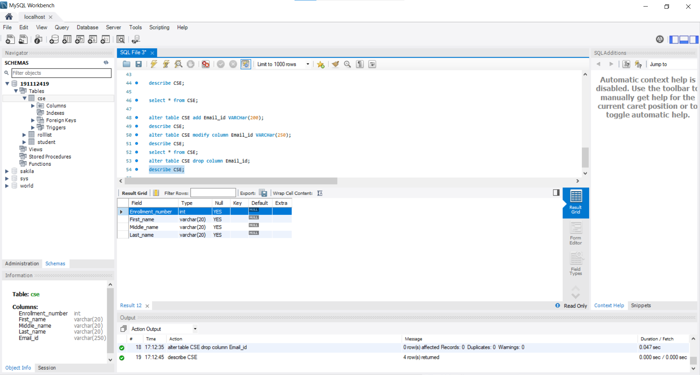

**Prog.5:** Delete all the record of table ‘**CSE’**

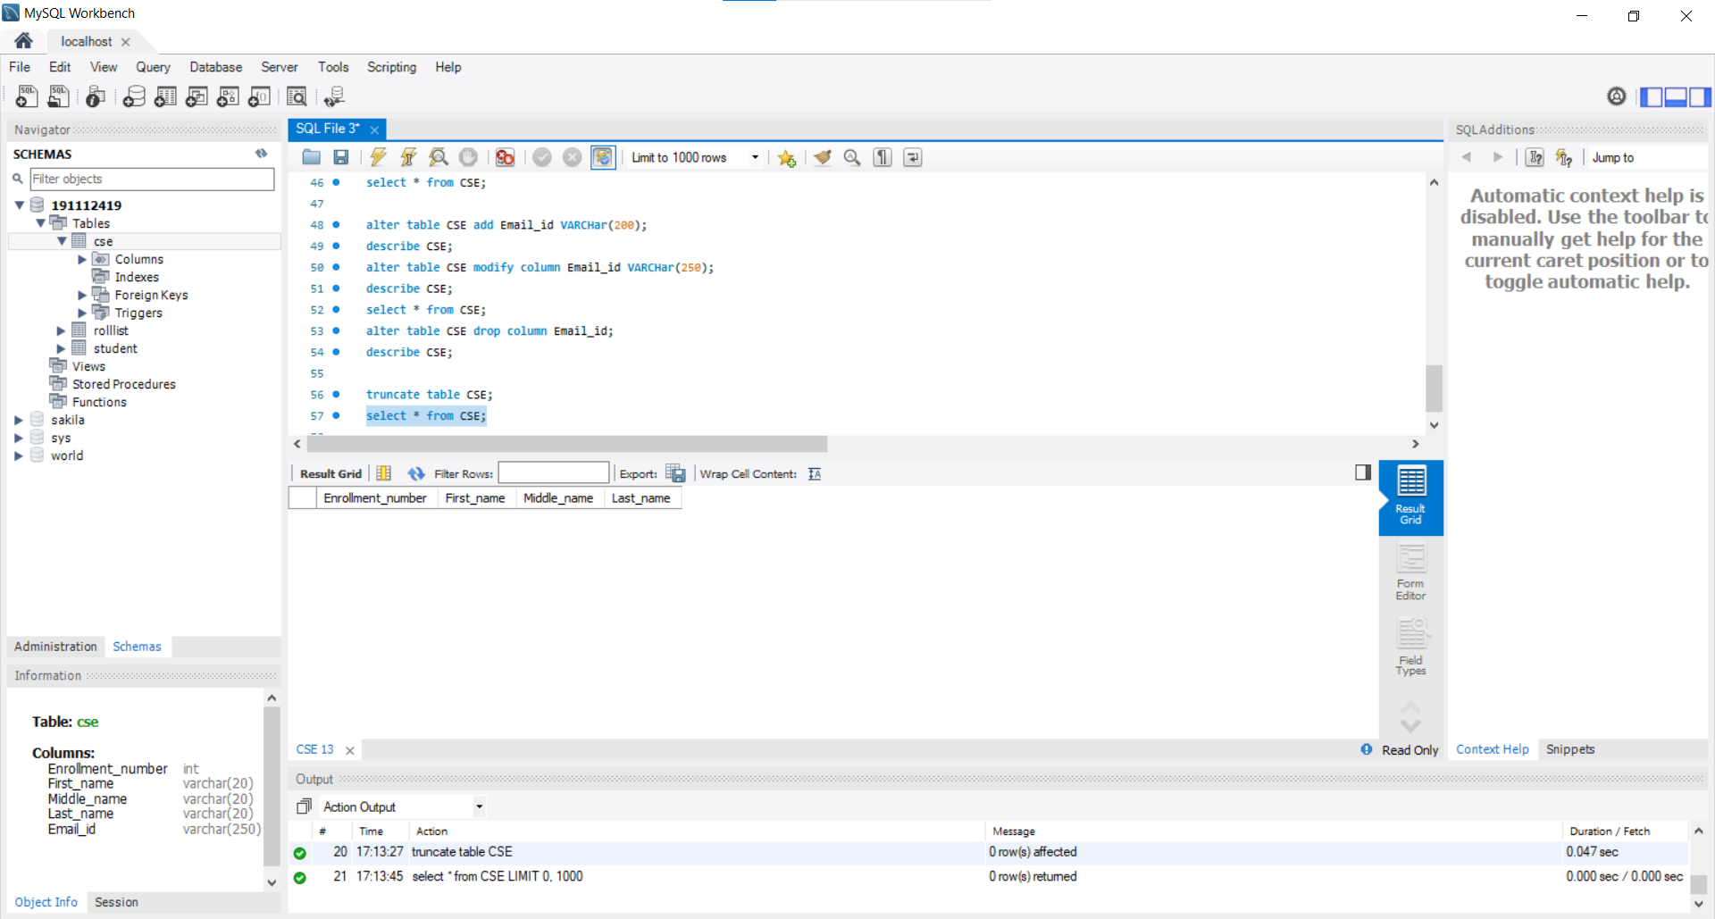

**Prog6:** Delete the structure of whole table ‘CSE’

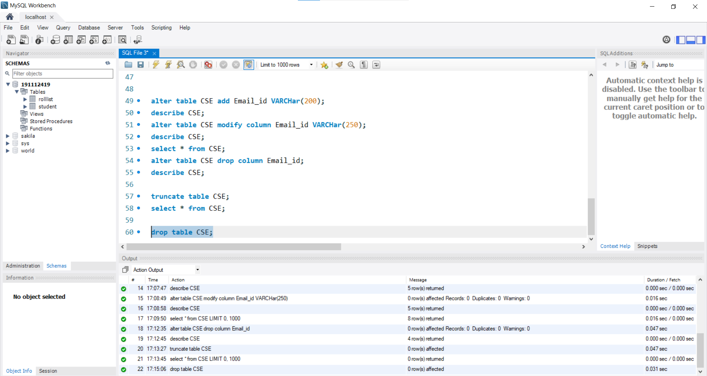

**All SQL Commands of the assignment.**

INSERT INTO student VALUES

(191112419, "Vivek", "Kumar", "Ahirwar", "CSE", "C-1/10 Rishi Nagar", "Ujjain", "M.P.", 456010);

select * FROM STUDENT;

INSERT INTO student VALUES

(191112251, "Ayush", "Singh", "Patel", "CSE", "Ghantaghar", "Khandwa", "M.P.", 450001 ),

(191112450, "Yuvraj", "Singh", "Rathore", "CSE", "Jethari", "Anuppur", "M.P.", 484224),

(191112053, "Uday", "", "Chaturvedi", "CSE", "B-133 Chirahula Colony", "REWA", "M.P.", 486001 ),

(191112341, "Priya", "", "Gupta", "CSE", "Bichhiya", "Rewa", "M.P.", 486001 ),

(191112024, "Bhushan", "Singh", "Sharma", "CSE", "MPNagar", "Bhopal", "M.P.", 462004),

(191112423, "Ankit", "", "Sharma", "CSE", "Ridhi Sidhi Nagar", "Kota", "Rajasthan", 324008),

(191112202, "Amit", "", "Rajak", "CSE", "Ram Nagar", "Vidhisha", "M.P.", 464001),

(191114035, "Karuna", "", "Sharma", "ECE", "A P Sabha", "Lucknow", "U.P.", 226003 ),

(191114001, "Mahesh", "Kumar", "Saran", "ECE", "TTNagar", "Bhopal", "M.P.", 462001),

(191114002, "Rajat", "", "Meena", "ECE", "New City", "Jabalpur", "M.P.", 482001),

(191114003, "Dilip", "Kumar", "Dole", "ECE", "Vijay Nagar", "Balaghat", "M.P.", 462004),

(191114004, "Pranav", "", "Gupta", "ECE", "Bangali Mohalla", "Indore", "M.P.", 451010);

select * FROM STUDENT;

INSERT INTO student VALUES

( 191116042, "Anurag", "Prasad", "Pandey", "Mechanical", "Near Sanchi stoop", "Vidisha", "M.P.", 464001 ),

( 191113054, "Sandeep", "", "Shukla", "Electrical", "Near global institute", "Jabalpur", "M.P.", 482001 ),

( 191116043, "Abhishek", "", "Dwivedi", "Mechanical", "Vijay Nagar", "Indore", "M.P.", 452010 ),

( 191113058, "Vijay", "Pratap", "Singh", "Electrical", "Bhawarkua", "Indore", "M.P.", 452014),

( 191117001, "Anushka", "", "Pandey", "Chemical", "C-67 sambhav nagar", "Surat", "Gujarat", 335009 ),

( 191113012, "Divya", "", "Tiwari", "Electrical", "C A Park", "Allahabad", "U.P.", 211001 ),

( 191116074, "Krishna", "Kumar" , "Shrivastava", "Mechanical", "A N L Colony", "Lucknow", "U.P.", 226001 );

select * FROM STUDENT;

create table Rolllist

as select Enrollment_number, First_name, Middle_name, Last_name from student;

describe Rolllist;

select * from rolllist;

create table CSE as

select Enrollment_number, First_name, Middle_name, Last_name from student where branch = "CSE";

describe CSE;

select * from CSE;

alter table CSE add Email_id VARCHar(200);

describe CSE;

alter table CSE modify column Email_id VARCHar(250);

describe CSE;

select * from CSE;

alter table CSE drop column Email_id;

describe CSE;

truncate table CSE;

select * from CSE;

drop table CSE;